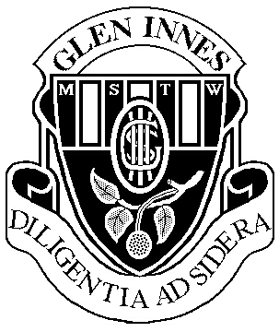
2024 HSC Assessment Schedule

Legal Studies – Year 12
Board Developed No of Units:2 Units

Task number | Task 1 | Task 2 | Task 3 | Task 4
Nature of task | Extended Response and In class test  Crime | Research Task  Human Rights | Research Task  Family Law | Trial HSC Exam
Timing | Term 4, Week 10 | Term 1, Week 9 | Term 3, Week 1 | Term 3, Week 4-5
Outcomes assessed | H1, H3, H6, H7, H8, H9 | H1, H2, H3, H4, H7, H8, H9, H10 | H1, H4, H5, H7, H8, H9, H10 | H1, H3, H4, H5, H7, H9, H10
Components | Weighting %
Knowledge and understanding of course content | 10 | 5 | 5 | 20
Analysis and Evaluation | 5 | 5 | 5 | 5
Inquiry and research | 5 | 5 | 10
Communication of legal information, ideas and issues in appropriate forms | 5 | 5 | 5 | 5
Total % | 25 | 20 | 25 | 30

H1. identifies and applies legal concepts and terminology
H2. describes and explains key features of and the relationship between Australian and international law
H3. analyses the operation of domestic and international legal systems
H4. evaluates the effectiveness of the legal system in addressing issues
H5. explains the role of law in encouraging cooperation and resolving conflict, as well as initiating and responding to change
H6. assesses the nature of the interrelationship between the legal system and society
H7. evaluates the effectiveness of the law in achieving justice
H8. locates, selects, organises, synthesises and analyses legal information from a variety of sources including legislation, cases,
media, international instruments and documents
H9. communicates legal information using well-structured and logical arguments
H10. analyses differing perspectives and interpretations of legal information and issues.

