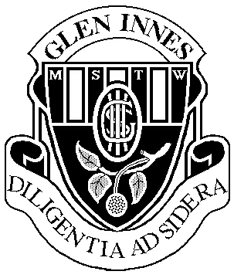
2023- 2024 HSC Assessment Schedule

Modern History – Year 12
Task number | Task 1 | Task 2 | Task 3 | Task 4
Nature of task | Source Analysis  Core  Power & Authority in the Modern World  1919 - 1948 | Research and in class response  National Study  Japan  1904 - 1937 | Historical Analysis  (Hand in task)  Peace and Conflict  Conflict in Europe | Trial HSC Exam
Timing | Term 4, Week 9 | Term 1, Week 9 | Term 2, Week 6 | Term 3, Week 4-5
Outcomes assessed | MH12-3, MH12-5,  MH12-6, MH12-9 | MH12-1, MH12-2,  MH12-3, MH12-5,  MH12-9 | MH12-2, MH12-4, MH12-6, MH12-7, MH12-9 | MH12-1, MH12-2, MH12-3, MH12-4, MH12-5, MH12-6, MH12-7, MH12-9
Components | Weighting %
Knowledge and understanding of course content | 10 | 5 | 5 | 15
Historical skills in the analysis and evaluation of sources and interpretations | 5 | 5 | 5 | 5
Historical inquiry and research | 5 | 5 | 10
Communication of historical understanding in appropriate terms | 5 | 10 | 5 | 5
Total 100% | 25 | 25 | 25 | 25
Outcomes
MH12-1: Accounts for the nature of continuity and change in the modern world
MH12-2: proposes arguments about the varying causes and effects of events and developments
MH12-3: Evaluates the role of historical features, individuals, groups and ideas in shaping the past
MH12-4: Analyses the different perspectives of individuals and groups in their historical context
MH12-5: Assesses the significance of historical features, people, ideas, movements, events and developments of the modern world
MH12-6: Analyses and interprets different types of sources for evidence to support an historical account or argument
MH12-7: Discusses and evaluates differing interpretations and representations of the past
MH12-8: Plans and conducts historical investigations and presents reasoned conclusions, using relevant evidence from a range of sources
MH12-9: communicates historical understanding, using historical knowledge, concepts and terms, in appropriate and well-structured forms

