America in Prime Time
Episode 1 – Man of the House
- One of the big concerns portrayed by men in tv is the feeling of being out of control. The men are trying to keep it all together.
- Families in the 1950’s were not represented accurately on tv. If this is the case, why did so many people tune in each day to see their favourite tv shows?
- By the late 1960’s – rise of civil rights movement and women’s movement etc
Straight down the line patriarchal family no longer relevant.
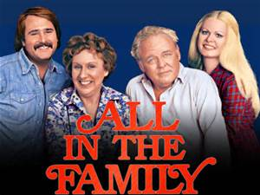
‘All in the Family’ (1971-1979)
-Pushed boundaries – the show started out with a disclaimer – the network didn’t’ want people to watch the show because it was so controversial. Archie Bunker was very racist eg. “I'm not racist! I'll be the first to say it, it's not their fault they're colored!"-- Archie Bunker

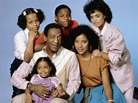
“The Cosby Show” (1984-1992)
By the 1980’s Dad’s were weak, bumbling etc. The exception to this was Bill Cosby. The Cosby Show allowed parents to take the control back in the home.
Theo: You're a doctor and Mom's a lawyer, and you're both successful in everything and that's great! But maybe I was born to be a regular person and have a regular life. If you weren't a doctor, I wouldn't love you less, because you're my dad. So rather than feeling disappointed because I'm not like you, maybe you should accept who I am and love me anyway, because I'm your son.
Cliff: Theo... that's the dumbest thing I've ever heard in my life! No wonder you get D's in everything! You're afraid to try because you're afraid your brain is going to explode and it's going to ooze out of your ears. Now I'm telling you, you are going to try as hard as you can. And you're going to do it because I said so. I am your father. I brought you into this world, and I'll take you out!
- The theme that cuts across all male characters and men in life is that they are unable to live up to some standard set by society.
- Homer Simpson is an example of a father figure out of control.
- The role of men in television has been cyclical. Man in charge – out of control – in charge again.

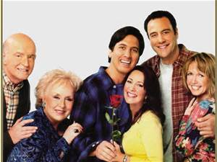
“Everybody Loves Raymond” (1996-2005)
In this, Ray is a father and man who is somewhat emasculated by the women in his life.
This show reflects social change that the man is no longer the rock of the family.

- Are television shows a product of the tastes of the television audience or are they in fact shaping the audience?

Episode 2 – The crusader
- After WWII Americans were feeling masculine. They were successful in the war and had shown their strength as a nation.
- From this stemmed the idea that men were supposed to be heroic.
- No heroic deed ever happens without a cost. If there is no cost it is not truly heroic.
- In television there are not many lone female crusaders. Is this because these ideas appeal mainly to men?

The choice between right and wrong.
- The audience always knew the main characters would make the right choice in the end. But what if the choices presented were both wrong? In this case the ethical boundaries are being stretched. Is violence actually a part of the human condition?

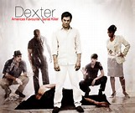
“Dexter” (2006-2014)
Take Dexter for example. He is an unlikely hero. Here is a main character that is not inherently ‘good’. The choices he makes on a day to day basis are not really about right and wrong. In fact, most of the time he has to choose between two wrongs. Yet somehow he is still appealing to the audience. Is Dexter a reflection of the idea that we acknowledge as a society that there is not always a clear cut right and wrong? It is not always evident that there is a good and bad. Perhaps we are giving ourselves as an audience the permission to be wrong, flawed etc.

- Is television a reflection of societal values and guidelines? Or do audiences create the guidelines by what they choose to watch?

Episode 3 – The Independent Woman
- Women are trying to find their identity.
- The changes in television reflect the changing roles of women.
- Once television ‘brainwashed’ women. They had to be the perfect wife and mother.
- Women cannot live up to the ideal of false perfection.
- In the 1950’s-1960’s the roles of women were very defined.

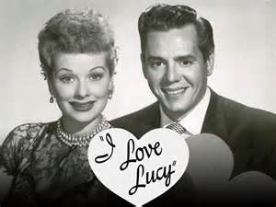
“I Love Lucy” (1951-1957)
Lucy was the first independent woman on television. Lucy doesn’t give up on wanting to be more than a wife. She also wants to be a part of her husband Ricky’s show. To entertain. This show demonstrated the eternal struggle between men and women.

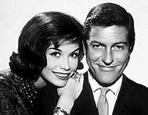
“The Dick Van Dyke Show” (1961-1966)
Mary Tyler Moore played the independent woman that was starting to emerge in society at that time.

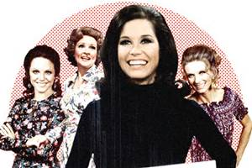
“The Mary Tyler Moore Show” (1970-1977)
This show was one of the first that showcased the ‘business woman’. It came about at the same time as the women’s liberation movement. Mary was happy being single and focussed on her career. The show was not intended to be a ‘soap box’; it was not about preaching women’s liberation, it was just a comedy show that happened to be in an interesting time period. The women’s movement did however help shine a light on the old stereotypes.

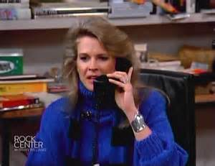
“Murphy Brown” (1988-1998)
Murphy started out as a character who had been in rehab. The network however didn’t like this and tried to turn the character into a woman who had just returned from a spa. The attributes of being a recovering alcoholic were not deemed as being a feminine quality that would translate well on television. This was despite the fact that other shows, namely ‘Cheers’ which had recovering alcoholic Sam Malone as the central character, portrayed similar characters and had achieved great success. The only difference was the gender of the character.

“Roseanne” (1988-1997)
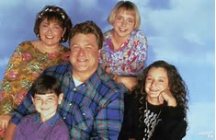
At this period in time it was felt that the ‘real’ family was not reflected in television shows. Roseanne became the first show to give a real representation of the mother character. Roseanne was middle class, made mistakes, was trying to juggle her marriage and children with work. She was harsh and abrasive at times but was very relatable to the audience because they could see a part of themselves in the show. No longer were audiences trying to live up to the unrealistic expectations of ‘perfect’ mothers on television.

- Television is a business. A 30 minute show is actually a 22 minute show. The rest is advertising.
- Cable television doesn’t have the same restraints as network television. Viewers pay for a subscription and so the networks are not as reliant on advertising which makes it possible for cable to show a more diverse range of programing.

“Sex and the City” (1998-2004)
This is an example of a more diverse program that started on cable television. It was the first time the audience sees female characters talking openly and frankly about all aspects of life including sex. The characters were able to take on more traditionally ‘male’ roles as they were not frowned upon for having casual sexual encounters and discussing these with each other.

“Desperate Housewives” (2004-2012)
This was influenced by Sex and The City but these women can’t share everything. You never really know what goes on behind closed doors. The character Lynette doesn’t like being a mother which had not been shown on television before. The show was also ground breaking in that the idea of the professional woman and the woman who has it all had become so widespread that women no longer respected those who chose to be housewives.

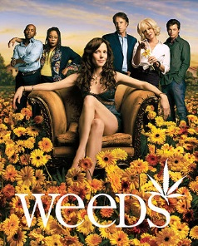
“Weeds” (2005-2012)
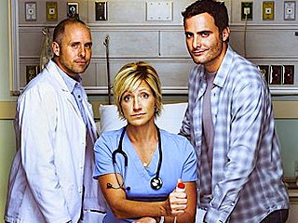
Weeds challenged the idea of women having to be pristine and moral on television. The central character Nancy Botwin was anything but! After the death of her husband, Nancy had to try and find a way to continue to live in the lifestyle she and her 2 sons had which was upper middle class and privileged and so she turns to drug dealing to bring in the money. Over the course of the show, she and her family become increasingly entangled in illegal activities.

“Nurse Jackie” (2009-current)
Nurse Jackie continued the trend of women in television not being perfect. She is a nurse who battles with addiction issues. It has become apparent that flawed characters are more relateable in today’s society.

- Through television shows we can see that women don’t HAVE to be anything anymore. There is far more choice for women and their roles in life nowadays.

Episode 4 – The Misfit

- The misfit is basically a character with zero self-awareness, someone who doesn’t fit in to the world of the audience.
- It can be said that we are now living in the ‘Age of the Nerds’. – Being an outcast or a nerd is a universal experience. Not everyone gets along with others and fits in and those that do, do not necessarily always feel this way.

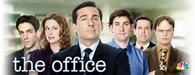
“The Office” (2005-2013)
The characters are social misfits and nerds. They are all of us and none of us at the same time. Through the use of comedy the characters are being ‘picked on’. When this occurs to the ‘misfit’ and they are ok and get through it with no issues, we as an audience feel better.

- Shows like “Taxi” and “Seinfeld” were shows about misfits. The characters were not traditional and didn’t try to fit in. They expected the world to fit in with their uniqueness instead.
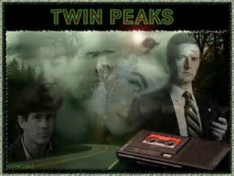
“Twin Peaks” (1990-1991)

Twin Peaks really brought about the notion that people always appear ‘normal’ but when you really get to know them they are a bit weird. This show was one of the first to really showcase the difference between a nice small town image and the dark underbelly of society. Things are not always as they appear. This show really tapped in to the audiences like of things that are unusual and bazar.

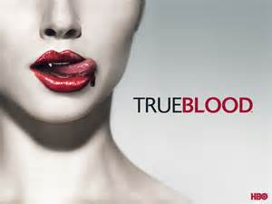
“True Blood” (2008-2014)
True Blood capitalised on the questions of ‘what is normal?’ and ‘why do we turn on people that aren’t?’. The show portrayed vampires who were seeking equality in society. It shows what it is like to be an outsider or someone different yet it does so in a fantastical way. Real issues can be addressed without really putting the spotlight onto reality. Eg. Equality is central theme but the inequalities of real life are not addressed.

“The United States of Tara” (2009-2011)
Again this show promotes the idea that being abnormal is in fact normal. Tara is deeply flawed and struggling day to day with having Identity Dissociative Disorder but she is also fundamentally a good mother and wife. The show again appeals to the idea that it is ok to not be perfect and you can still be a good person even though you do not fit the stereotype of the 1950’s woman.

“Freaks and Geeks” (1999-2000)
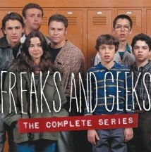
Freaks and Geeks is a television show about two unique groups of teenagers dealing with life in high school during the 80's. If you were popular in high school you were in the centre of it all. However, if you were different you were the observer. This idea is shown in the way storylines are told in television shows. This show reflects the idea that everyone is simply trying to find their own place in life.

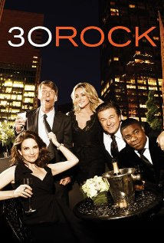
The Narcissist
“30 Rock” (2006-2013)
Liz Lemon, head writer of the sketch comedy show "TGS with Tracy Jordan", must deal with an arrogant new boss and a crazy new star, all while trying to run a successful TV show without losing her mind.
The narcissist character is aptly showcased in this series by the character of Jack Donaghy, the arrogant boss portrayed by Alec Baldwin. This is a character only out for number one; himself.

Jack: Come on, Lemon. What do we elites do when we screw up? We pretend it never happened and give ourselves a giant bonus.

Misfits no longer think little of themselves. They happily take on the role of being a misfit. No matter how outrageous the character, there is an element of truth to the character. This truthful element allows audiences to identify with certain characteristics and even take pride in them. There is no longer an emphasis on conformity in society.

