Webquest: 47 Ronin!
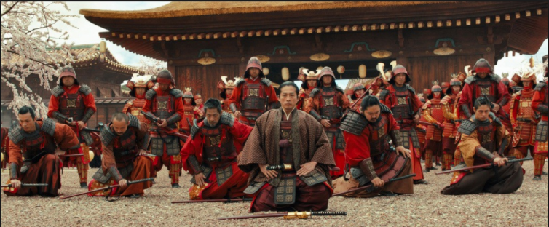

Go to the following website: http://www.47ronins.com/
On the site you will find a menu on the left. Navigate through this menu to help you answer the questions below.

Introduction
- What are the 47 Ronin also known as?
- What date did this story begin?
- Why was lord Asano Naganori forced to commit ritual suicide?
- Who was Kira Yoshinaka?
- Why did the 47 Ronin raid Kira’s mansion?
- How are the 47 Ronin regarded today?

Understanding Bushido
- What is Bushido?
- Where does Bushido find it’s origins?
- What does Bushido ask of the samurai?
- If a samurai loses their honour what could he do to regain it?
- What is seppuku?

Tragedy in Edo castle
- What does Daimyo mean?
- Why was Kira to instruct Asano and Kamei in etiquette?
- What sort of man was Kira?
- How did he treat Asano and Kamei?
- What did Asano do that was considered to be a grave offence?
- What was Asano’s punishment?
- What would happen to the Shogun family when a Daimyo committed seppuku?
- What is a Ronin?
- Who was Oishi?
- How many men joined together to avenge their masters death?

Preparing the revenge
- What did Kira do to try to protect himself from Asano’s Samurai?
- How did the 47 Ronin get information on Kira?
- Why did Oishi go to Kyoto?
- Why did Kira believe that Asano’s Ronin did not have the courage to avenge their master?

The Ronin’s attack
- How long after Asano’s death did his Ronin attack Kira?
- What was the date of this attack?
- Why did the neighbours do nothing to stop the Ronin?
- What sounded the beginning of the attack?
- What happened t many of Kira’s men when the Ronin attacked?
- Where did Kira hide during the attack?

The Death of Kira
- How was Kira identified?
- Why did Oishi kneel down to Kira?
- What was offered to Kira?
- How did Oishi realise Kira did not have the courage to commit sepukku?
- How did Kira die?

The Sentence
- The Ronin new they would be facing death for their actions. Why were they treated with courtesy and respect?
- How long did the Shogunate deliberate on the punishment?
- Why did it take so long to reach a decision?
- What were the Ronin sentenced to do?
- What date did this happen?
- Why do people visit their tombs today?

The Legend Lives On
- What does the story of the 47 Ronin illustrate and what does it represent?

