**Year 11 S&C Revision So Far…**

**1) The five fundamental concepts are:**

a) _____________________ d) _____________________

b) _____________________ e) _____________________

c) _____________________

**2) The other four main concepts include:**

a) Power b) _____________________

c) _____________________ d) _____________________

**3) The following commentaries come from some of the concepts. Identify which one in the space provided:**

a) “...individuals who are shaped by their society and culture” _______________

b) “...choose to measure it in terms of past, present and future” _______________

c) “...implies a legitimate use of influence and/or persuasion” _______________

d) “...the tools that make tasks easier....” _______________

**4) The following diagram explains how we arrive at a point of .... (answer in the box)**



**5) Match the following concepts to the correct meaning in the space below the table:**

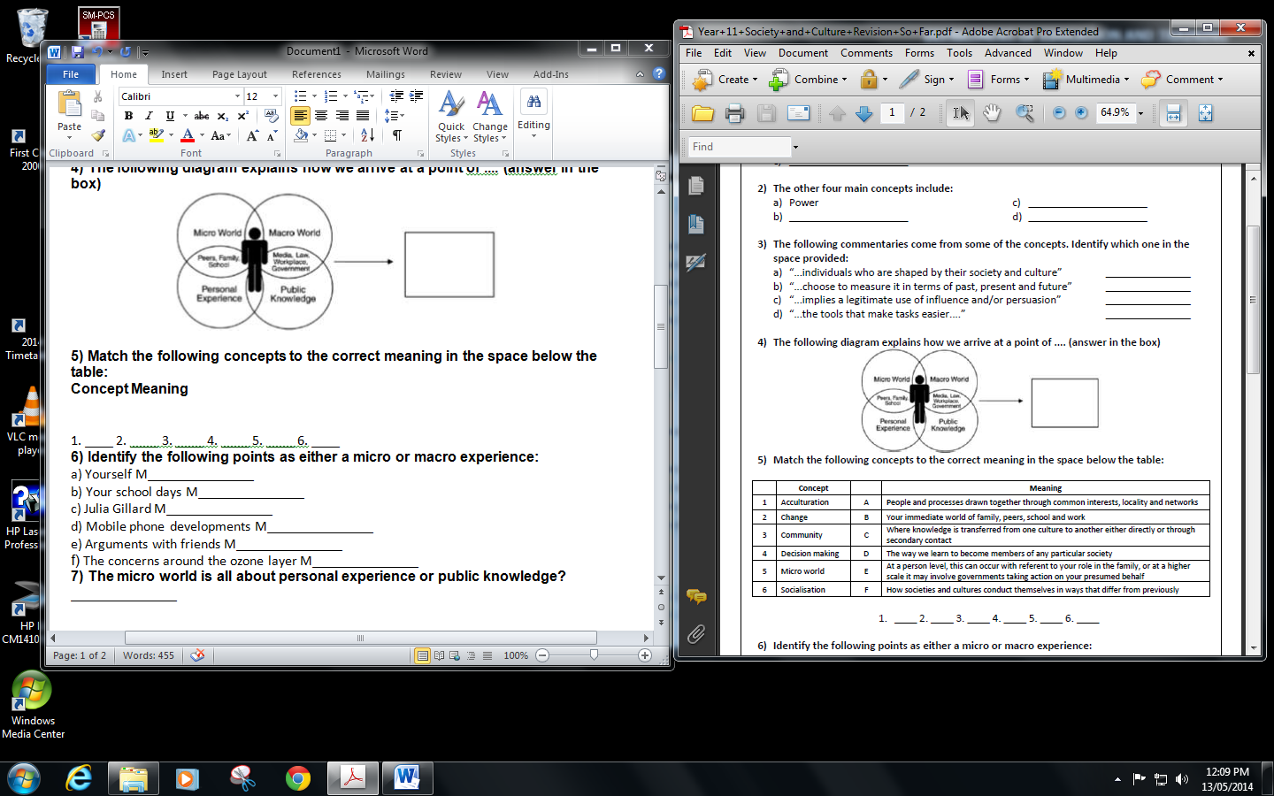

1. ____ 2. ____ 3. ____ 4. ____ 5. ____ 6. ____

**6) Identify the following points as either a micro, meso or macro experience:**

a) Yourself M_______________

b) Your school days M_______________

c) Julia Gillard M_______________

d) Mobile phone developments M_______________

e) Arguments with friends M_______________

f) The concerns around the ozone layer M_______________

**7) The micro world is all about personal experience or public knowledge?** _______________

**8) Good responses to S&C questions will ideally combine personal experience and public knowledge.**

True/False

**9) Which factors belong to the sphere or personal experience (PE) and which belong to public knowledge (PK):**

a) Research P___ e) Community life P___

b) Family life P___ d) Media P___

c) Peer group P___

**10) Society and Culture draws on several inter-disciplinary areas for its enquires. Name three:**

_____________________ _____________________ _____________________

**11) Data that is measured is called** ______________________ **research**

**12) Data that has to be interpreted is called** ___________________ **research**

**13) Identify if these are examples of quantitative or qualitative research methodologies.**

a) Using graphs __________________

b) Use small samples of data __________________

c) Personal opinions __________________

d) Using diagrams __________________

e) Open ended questionnaires __________________

f) Structured interviews __________________

g) Participant observation __________________

h) Use large samples of data __________________

i) Using tables __________________

j) Interpretation __________________

**14) Describe the stages in the process of social and cultural research**

a) Clearly de________ your topic or question. Try to be as ____________ific as possible.

b) Start p__________. Break your research into _____________able sections. Set yourself

achievable targets.

c) Starting reading ___________________ research on your topic.

d) Choose your m___________________s. Make sure they are all appropriate.

e) Co_______________ relevant facts.

f) ______________se and __________ret all the data you have collected.

g) E____________ your methodologies and the way you have used them

h) Present your findings using a variety of relevant forms of c________________

**15) Identify the following research methodologies:**

a) ________________ analysis d) Stati____cal _____________

b) Q______________________ e) In________________

c) Ob_____________________