Year 7 History Revision

**1. Glossary**

Put the correct word from the word bank below next to its correct meaning.

|  |  |
| --- | --- |
|  | A stone coffin, often inscribed or decorated with sculpture |
|  | a person educated in the arts of writing |
|  | a character of the ancient Egyptian writing system. |
|  | a document or physical object which was written or created during the time under study |
|  | a way of displaying a list of events in chronological order |
|  | Someone who studies past human societies by recovering, recording, analysing and interpreting material remains and other evidence |
|  | any source about an event, period, or issue in history that was produced after that event, period or issue has passed |
|  | Hand-operated device for lifting water |
|  | scientific method of dating based on the analysis of patterns of tree rings |
|  | people who move from place to place without settling |
|  | a person who studies and writes about the past and is regarded as an authority on it |
|  | A vault or chamber for burial of the dead |
|  | the preserved remains or traces of animals |
|  | the preservation of a body, either animal or human |
|  | show inclination or prejudice for or against someone or something |
|  | A beetle worshiped by Ancient Egyptians |
|  | an object made by a human being, typically one of cultural or historical interest |
|  | Paper-like material made from the stem of a plant used by ancient Egyptians |
|  | the arrangement of events or dates in the order of their occurrence |
|  | a period of 10 years |
|  | The part of ancient Egypt comprising the Nile River delta |
|  | the process of sanitizing, preserving, and restoring a deceased human body to a more life-like appearance. |
|  | a mythical creature with a lion's body and a human head |

Shaduf, Hieroglyph, embalming, sphinx, scarab, sarcophagus, mummification, decade, artefact, lower Egypt, scribe, papyrus, tomb, bias, primary source, secondary source, chronology, dendrochronology, timeline, historian, archaeologist, nomad, fossils

**2. Match each of these items to the approximate year of its release [choose from the dates in the box].**

c. 1830

c. 2001

c. 1927

c. 1450



____________ ______________ ___________ ________________

List the above inventions in chronological order (from the earliest to the most recent):

___________________________________________________________________



**. Egyptian Farming Activity**

Source 1



Source 2



Egyptian Farming Source Activity Questions

Decide which source offers the best evidence for each statement about

Egyptian farming

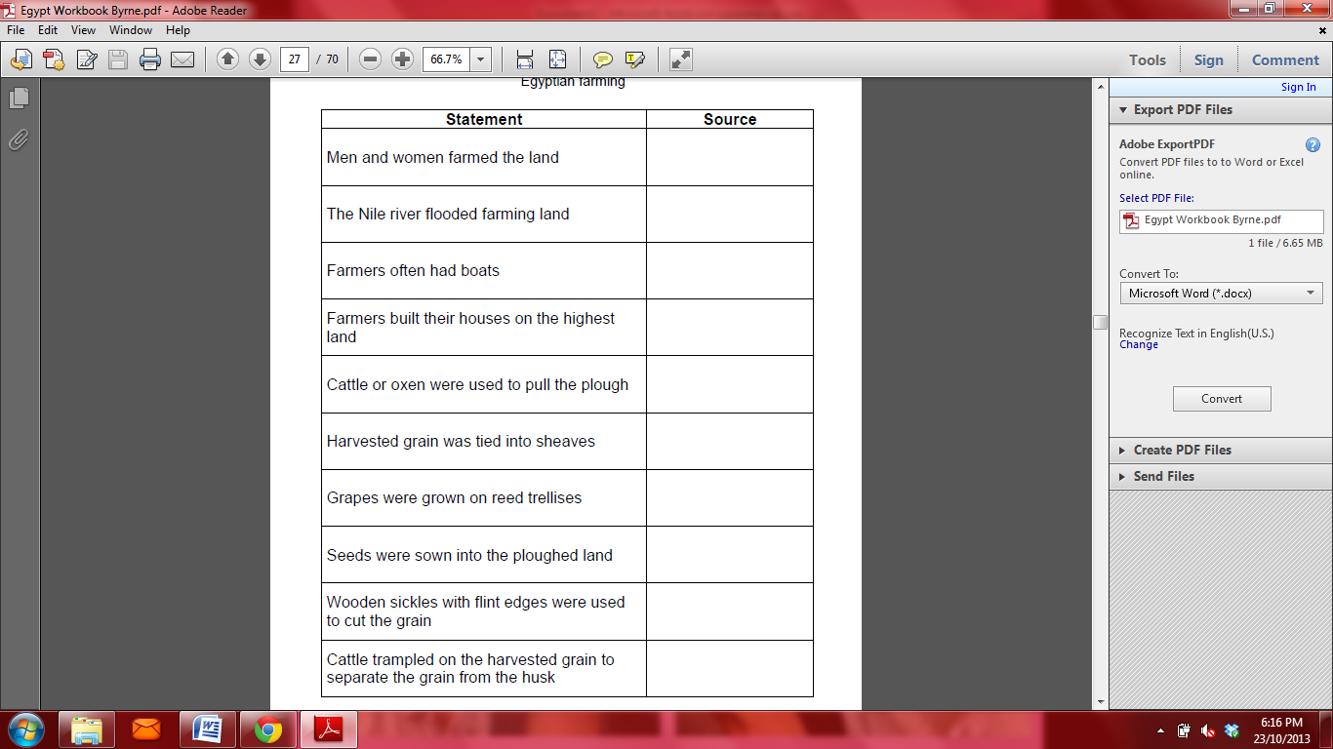

|  |  |  |  |  |  |  |  |  |  |  |
| --- | --- | --- | --- | --- | --- | --- | --- | --- | --- | --- |
| **4. Ancient Egypt Cloze**  Fill in the blanks with the words in the boxes. | | | | | | | | **pyramids4** | | |
| **Civilization on the Nile River** | | | | | | | |
| transportation | | | Desert | | thousand | | pyramids | | | Nile |
| Ancient Egyptian civilization, which is famous for its colossal ____________________ began over five ____________________ years ago. It was centered around the ____________________ River and surrounded by the inhospitable Sahara ____________________. The ancient Egyptians depended on the Nile for everything from water to ____________________. | | | | | | | | | | |
| **Floods and Irrigation** | | | | | | | | | | |
| irrigate | | tears | | | crops | | flood | | | fertile |
| Though it almost never rains in the Nile River Valley, rains in the far away Ethiopian Highlands cause the Nile River to ____________________ every year. Ancient Egyptians believed that these yearly floods were caused by the ____________________ of the goddess Isis. The floods carried rich soil with them, covering the Nile Delta with ____________________ soil for growing ____________________. Ancient Egyptians created an elaborate system of ditches and canals to _________________ their crops with the flood waters. | | | | | | | | | | |
| **Pharaohs** | | | | | | | | | | |
| tombs | | | | pharaohs | | crown | | | Great House | |
| The ancient Egyptians were ruled by the ____________________, a title that means ____________________. The pharaohs wore a double ___________________, which represented their rule over Upper and Lower Egypt. When the pharaohs died they were buried in elaborate ___________________. | | | | | | | | | | |
|  | | | | | | | | | | |
| **Egyptian Writing** | | | | | | | | | | |
| walls | | | | scribes | | picture | | | papyrus | |
| hier | Ancient Egyptians developed a system of ____________________ writing called hieroglyphics. Ancient Egyptians recorded their beliefs using hieroglyphics on temple and tomb ____________________. They also wrote on scrolls made from ____________________. People who could write were important government officials called ____________________. | | | | | | | | | |

**5. Mummification**

Anubis (Ancient Egyptian God of the dead) has lost his instructions on how to make a mummy. He has asked for your help. Place a number from 1 – 8 under each picture placing them in the correct order.

|  |  |
| --- | --- |
| http://www.ancientegypt.co.uk/mummies/story/images/pro03.gifYTC6184http://www.ancientegypt.co.uk/mummies/story/images/pro02.gif | pro06brainhttp://www.ancientegypt.co.uk/mummies/story/images/canopic.gif |