Worksheet #11 The Berlin Wall

By the 1960s Berlin was still divided - the USSR controlled the East and the USA guaranteed freedom in the West. Thousands of refugees escaped to West Berlin each day - much to the embarrassment of the USSR - so in 1961 Khrushchev closed the border and ordered the construction of a wall to stop people leaving.
The problems in West Berlin
West Berlin was a worry and an embarrassment for the Soviet Union in 1961:
- Nearly 2,000 refugees a day were fleeing to the West through west Berlin - hardly proof of the Soviet claim that the Communist way of life was better than capitalism!
- Many of those leaving were skilled and qualified workers.
- The Soviets believed (rightly) that West Berlin was a centre for US espionage.
At the Vienna Summit of June 1961, therefore, Khrushchev demanded that the US leave West Berlin within six months. Kennedy refused and instead guaranteed West Berlin's freedom.
On 13 August, Khrushchev closed the border between East and West Berlin and started building the Berlin Wall. At first, the Russians regarded it as a propaganda success, but as time went on, it became a propaganda disaster - a symbol of all that was bad about Soviet rule.

The Berlin Wall as a symbol
Source A
A photograph of the Berlin Wall.
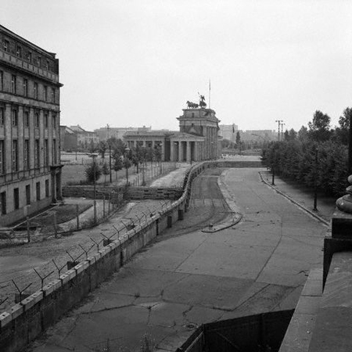
The Berlin Wall shortly after its construction

Source B
In 1963, President Kennedy visited West Berlin and made his famous 'I am a Berliner' speech next to the Berlin Wall:
There are many people in the world who really don't understand what is the great issue between the free world and the communist world - let them come to Berlin!
There are some who say in Europe and elsewhere we can work with the communists - let them come to Berlin!
All free men, wherever they may live, are citizens of Berlin. And, therefore, as a free man, I take pride in the words 'Ich bin ein Berliner' ['I am a Berliner']. President Kennedy, 1963

WORKSHEET QUESTIONS #11
1. When was the Berlin Wall created? Why did Krushchev have it constructed? What problems was he trying to deal with?

2. How was it a symbol of ideological division like the iron curtain?

3. What does the Berlin Wall tells us about the nature of the Cold War in the 1960s.

- Looking at the picture from Source A – what are your thoughts on this time in our history?
5. JFKs famous speech was undoubtedly propaganda. From what you read in Source B – what was his main point? How effective was it?

