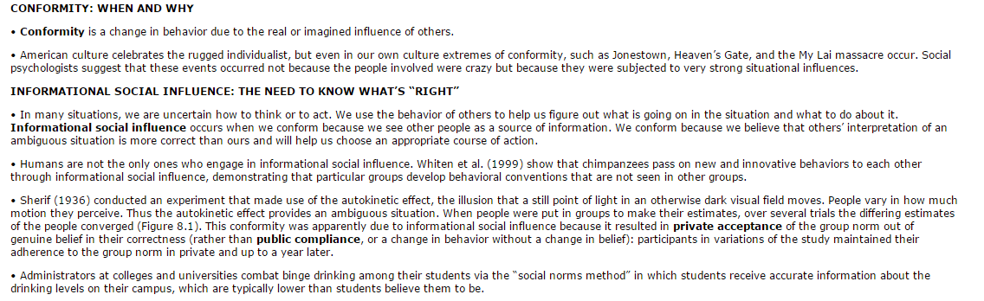

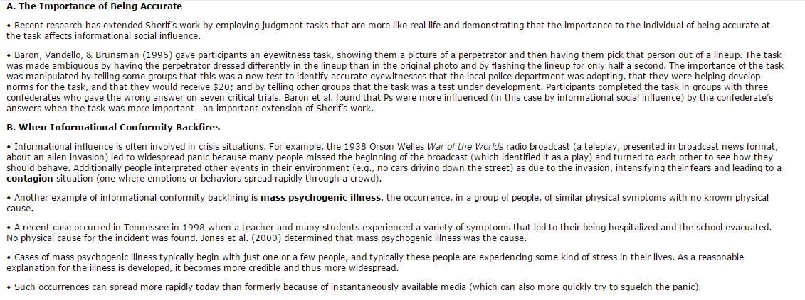

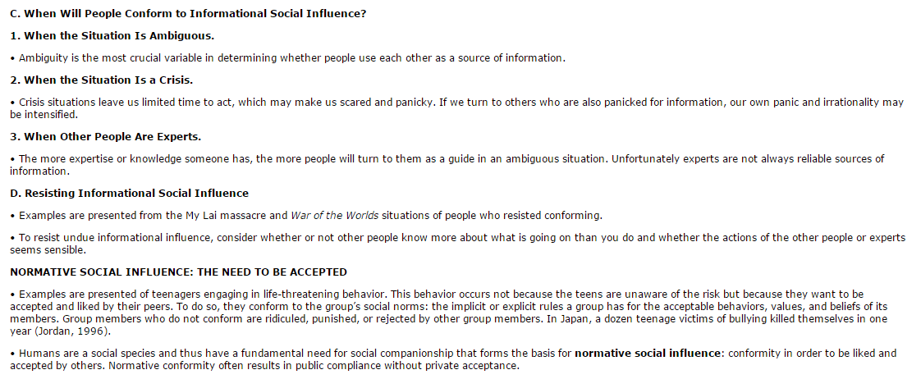

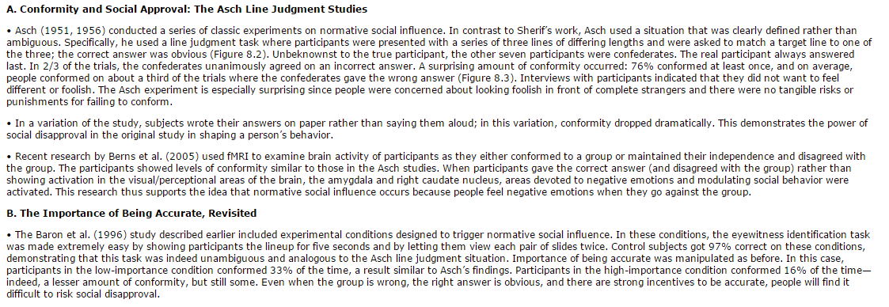

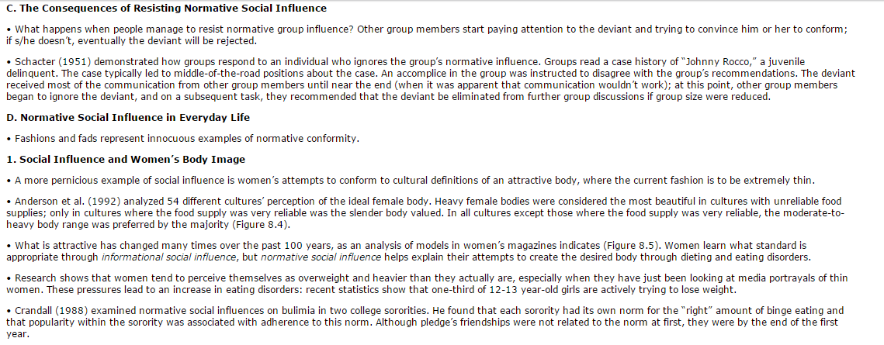

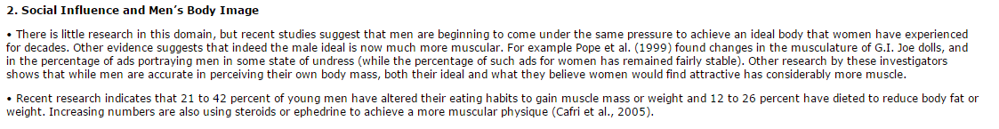

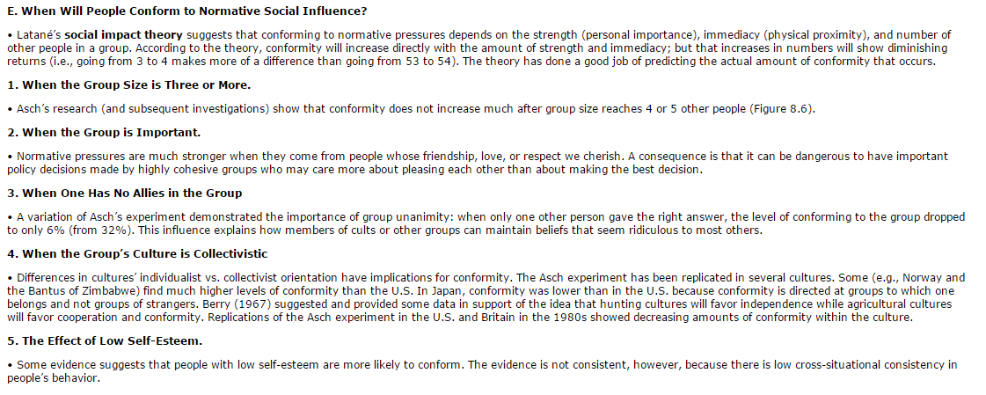

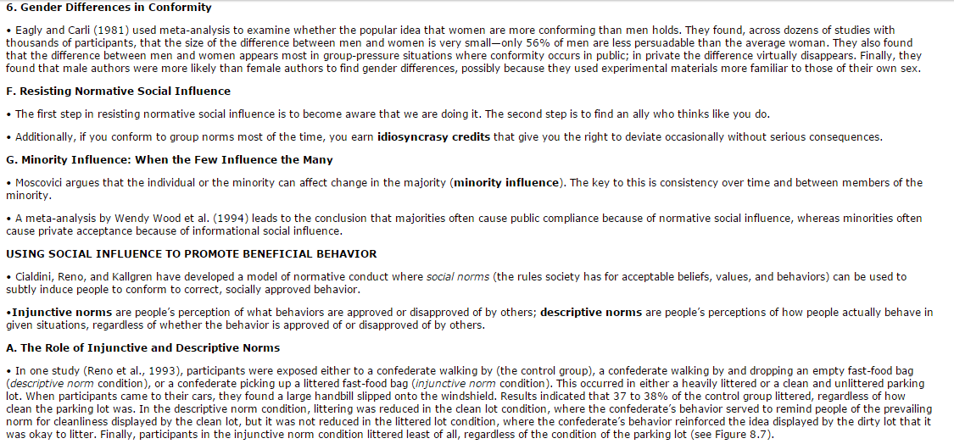

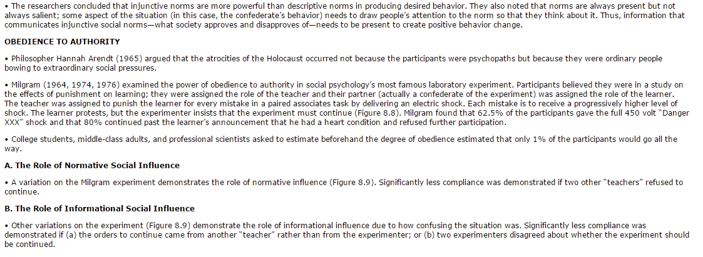

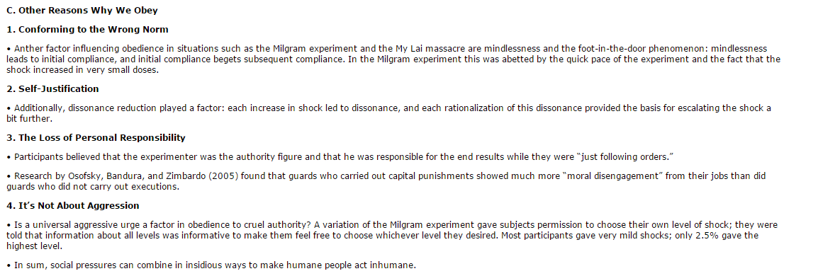

**Questions:**

Top of Form

|  |  |  |
| --- | --- | --- |
| http://wps.prenhall.com/wps/media/styles/1480/_skins_/D/default_blue/ps_bkgd_upper_left.gif | http://wps.prenhall.com/wps/media/styles/1480/_skins_/D/default_blue/pixel.gif | http://wps.prenhall.com/wps/media/styles/1480/_skins_/D/default_blue/ps_bkgd_upper_right.gif |
| http://wps.prenhall.com/wps/media/styles/1480/_skins_/D/default_blue/pixel.gif | |  |  | | --- | --- | |  | Question 1. **Results of Milgram's research on obedience to authority suggest that** | | http://wps.prenhall.com/wps/media/styles/1480/_skins_/D/default_blue/problem_type_1.gif | |  | |  |  | | --- | --- | |  | normative and informational social influence play no role in obedience. | |  | people will do things they do not want to do, and that maybe dangerous, if an authority orders them to. | |  | altering the situation led to few changes in the responses of participants. | |  | people in general are cruel and enjoy giving electric shocks to others. | | | http://wps.prenhall.com/wps/media/styles/1480/_skins_/D/default_blue/pixel.gif |
| http://wps.prenhall.com/wps/media/styles/1480/_skins_/D/default_blue/ps_bkgd_lower_left.gif |  | End of Question 1 |
| http://wps.prenhall.com/wps/media/styles/1480/_skins_/D/default_blue/ps_bkgd_upper_left.gif | http://wps.prenhall.com/wps/media/styles/1480/_skins_/D/default_blue/pixel.gif | http://wps.prenhall.com/wps/media/styles/1480/_skins_/D/default_blue/ps_bkgd_upper_right.gif |
| http://wps.prenhall.com/wps/media/styles/1480/_skins_/D/default_blue/pixel.gif | |  |  | | --- | --- | |  | Question 2. **Which of the following will not lead to increases in conformity?** | | http://wps.prenhall.com/wps/media/styles/1480/_skins_/D/default_blue/problem_type_2.gif | |  | |  |  | | --- | --- | |  | when the group is from a collectivistic culture | |  | when the group is important to us | |  | when you have no allies in the group | |  | when the group's size becomes larger than 20 people | | | http://wps.prenhall.com/wps/media/styles/1480/_skins_/D/default_blue/pixel.gif |
| http://wps.prenhall.com/wps/media/styles/1480/_skins_/D/default_blue/ps_bkgd_lower_left.gif |  | End of Question 2 |
| http://wps.prenhall.com/wps/media/styles/1480/_skins_/D/default_blue/ps_bkgd_upper_left.gif | http://wps.prenhall.com/wps/media/styles/1480/_skins_/D/default_blue/pixel.gif | http://wps.prenhall.com/wps/media/styles/1480/_skins_/D/default_blue/ps_bkgd_upper_right.gif |
| http://wps.prenhall.com/wps/media/styles/1480/_skins_/D/default_blue/pixel.gif | |  |  | | --- | --- | |  | Question 3. **Ignoring the pressures of normative social influence** | | http://wps.prenhall.com/wps/media/styles/1480/_skins_/D/default_blue/problem_type_3.gif | |  | |  |  | | --- | --- | |  | can lead to negative consequences, but these are typically not very powerful. | |  | can lead to rejection and derogation. | |  | will lead to minimal consequences in most situations. | |  | none of the above. | | | http://wps.prenhall.com/wps/media/styles/1480/_skins_/D/default_blue/pixel.gif |
| http://wps.prenhall.com/wps/media/styles/1480/_skins_/D/default_blue/ps_bkgd_lower_left.gif |  | End of Question 3 |
| http://wps.prenhall.com/wps/media/styles/1480/_skins_/D/default_blue/ps_bkgd_upper_left.gif | http://wps.prenhall.com/wps/media/styles/1480/_skins_/D/default_blue/pixel.gif | http://wps.prenhall.com/wps/media/styles/1480/_skins_/D/default_blue/ps_bkgd_upper_right.gif |
| http://wps.prenhall.com/wps/media/styles/1480/_skins_/D/default_blue/pixel.gif | |  |  | | --- | --- | |  | Question 4. **Which of the following is primarily an example of normative social influence, but not informational social influence?** | | http://wps.prenhall.com/wps/media/styles/1480/_skins_/D/default_blue/problem_type_4.gif | |  | |  |  | | --- | --- | |  | You see someone laying in the gutter, but other people don't seem to be helping so you assume there's no emergency and move on. | |  | At a fishing tournament, you notice that everyone catching fish seems to be using a certain kind of lure, so you switch to that lure. | |  | At a new job, you notice your co-workers all take a donut break at 10:30, so you do too. | |  | A group of people you are with all describe their negative judgment of a person you like, and you agree with them in order to fit in. | | | http://wps.prenhall.com/wps/media/styles/1480/_skins_/D/default_blue/pixel.gif |
| http://wps.prenhall.com/wps/media/styles/1480/_skins_/D/default_blue/ps_bkgd_lower_left.gif |  | End of Question 4 |
| http://wps.prenhall.com/wps/media/styles/1480/_skins_/D/default_blue/ps_bkgd_upper_left.gif | http://wps.prenhall.com/wps/media/styles/1480/_skins_/D/default_blue/pixel.gif | http://wps.prenhall.com/wps/media/styles/1480/_skins_/D/default_blue/ps_bkgd_upper_right.gif |
| http://wps.prenhall.com/wps/media/styles/1480/_skins_/D/default_blue/pixel.gif | |  |  | | --- | --- | |  | Question 5. **Conformity can sometimes lead to the occurrence, in a group of people, of similar physical symptoms with no known physical cause. In other words it can lead to** | | http://wps.prenhall.com/wps/media/styles/1480/_skins_/D/default_blue/problem_type_5.gif | |  | |  |  | | --- | --- | |  | the autokinetic effect. | |  | contagion. | |  | normative social influence. | |  | mass psychogenic illness. | | | http://wps.prenhall.com/wps/media/styles/1480/_skins_/D/default_blue/pixel.gif |
| http://wps.prenhall.com/wps/media/styles/1480/_skins_/D/default_blue/ps_bkgd_lower_left.gif |  | End of Question 5 |
| http://wps.prenhall.com/wps/media/styles/1480/_skins_/D/default_blue/ps_bkgd_upper_left.gif | http://wps.prenhall.com/wps/media/styles/1480/_skins_/D/default_blue/pixel.gif | http://wps.prenhall.com/wps/media/styles/1480/_skins_/D/default_blue/ps_bkgd_upper_right.gif |
| http://wps.prenhall.com/wps/media/styles/1480/_skins_/D/default_blue/pixel.gif | |  |  | | --- | --- | |  | Question 6. **Milgram’s replication of Asch’s study in France and Norway concluded that** | | http://wps.prenhall.com/wps/media/styles/1480/_skins_/D/default_blue/problem_type_6.gif | |  | |  |  | | --- | --- | |  | Norwegians showed a higher rate of conformity. | |  | Both showed very low levels of conformity. | |  | The French showed a higher rate of conformity. | |  | Neither the French or the Norwegians showed high levels of conformity. | | | http://wps.prenhall.com/wps/media/styles/1480/_skins_/D/default_blue/pixel.gif |
| http://wps.prenhall.com/wps/media/styles/1480/_skins_/D/default_blue/ps_bkgd_lower_left.gif |  | End of Question 6 |
| http://wps.prenhall.com/wps/media/styles/1480/_skins_/D/default_blue/ps_bkgd_upper_left.gif | http://wps.prenhall.com/wps/media/styles/1480/_skins_/D/default_blue/pixel.gif | http://wps.prenhall.com/wps/media/styles/1480/_skins_/D/default_blue/ps_bkgd_upper_right.gif |
| http://wps.prenhall.com/wps/media/styles/1480/_skins_/D/default_blue/pixel.gif | |  |  | | --- | --- | |  | Question 7. **When confronted with orders from a perceived authority figure individuals** | | http://wps.prenhall.com/wps/media/styles/1480/_skins_/D/default_blue/problem_type_7.gif | |  | |  |  | | --- | --- | |  | Are more likely to obey without questions. | |  | Are more likely to question the orders if they don’t agree with them. | |  | Are more likely to disobey them. | |  | Will question the authority of the individual giving the orders. | | | http://wps.prenhall.com/wps/media/styles/1480/_skins_/D/default_blue/pixel.gif |
| http://wps.prenhall.com/wps/media/styles/1480/_skins_/D/default_blue/ps_bkgd_lower_left.gif |  | End of Question 7 |
| http://wps.prenhall.com/wps/media/styles/1480/_skins_/D/default_blue/ps_bkgd_upper_left.gif | http://wps.prenhall.com/wps/media/styles/1480/_skins_/D/default_blue/pixel.gif | http://wps.prenhall.com/wps/media/styles/1480/_skins_/D/default_blue/ps_bkgd_upper_right.gif |
| http://wps.prenhall.com/wps/media/styles/1480/_skins_/D/default_blue/pixel.gif | |  |  | | --- | --- | |  | Question 8. **Our perception of the way people behave in a given situation according to their effective or adaptive behavior is called _________________ .** | | http://wps.prenhall.com/wps/media/styles/1480/_skins_/D/default_blue/problem_type_8.gif | |  | |  |  | | --- | --- | |  | Injunctive Norm | |  | Specific norms | |  | Minority Influence | |  | Descriptive Norm | | | http://wps.prenhall.com/wps/media/styles/1480/_skins_/D/default_blue/pixel.gif |
| http://wps.prenhall.com/wps/media/styles/1480/_skins_/D/default_blue/ps_bkgd_lower_left.gif |  | End of Question 8 |
| http://wps.prenhall.com/wps/media/styles/1480/_skins_/D/default_blue/ps_bkgd_upper_left.gif | http://wps.prenhall.com/wps/media/styles/1480/_skins_/D/default_blue/pixel.gif | http://wps.prenhall.com/wps/media/styles/1480/_skins_/D/default_blue/ps_bkgd_upper_right.gif |
| http://wps.prenhall.com/wps/media/styles/1480/_skins_/D/default_blue/pixel.gif | |  |  | | --- | --- | |  | Question 9. **Public compliance always includes private acceptance.** | | http://wps.prenhall.com/wps/media/styles/1480/_skins_/D/default_blue/problem_type_9.gif | |  | True  False | | http://wps.prenhall.com/wps/media/styles/1480/_skins_/D/default_blue/pixel.gif |
| http://wps.prenhall.com/wps/media/styles/1480/_skins_/D/default_blue/ps_bkgd_lower_left.gif |  | End of Question 9 |
| http://wps.prenhall.com/wps/media/styles/1480/_skins_/D/default_blue/ps_bkgd_upper_left.gif | http://wps.prenhall.com/wps/media/styles/1480/_skins_/D/default_blue/pixel.gif | http://wps.prenhall.com/wps/media/styles/1480/_skins_/D/default_blue/ps_bkgd_upper_right.gif |
| http://wps.prenhall.com/wps/media/styles/1480/_skins_/D/default_blue/pixel.gif | |  |  | | --- | --- | |  | Question 10. **Ambiguous situations increase the influence of informational social influence.** | | http://wps.prenhall.com/wps/media/styles/1480/_skins_/D/default_blue/problem_type_10.gif | |  | True  False | | http://wps.prenhall.com/wps/media/styles/1480/_skins_/D/default_blue/pixel.gif |
| http://wps.prenhall.com/wps/media/styles/1480/_skins_/D/default_blue/ps_bkgd_lower_left.gif |  | End of Question 10 |
| http://wps.prenhall.com/wps/media/styles/1480/_skins_/D/default_blue/ps_bkgd_upper_left.gif |  | * http://wps.prenhall.com/wps/media/styles/1480/_skins_/D/default_blue/ps_bkgd_upper_right.gif |
| http://wps.prenhall.com/wps/media/styles/1480/_skins_/D/default_blue/pixel.gif | |  |  | | --- | --- | |  | Question 11. **Conformity in Asch's line judgment studies was primarily due to informational social influence.** | | http://wps.prenhall.com/wps/media/styles/1480/_skins_/D/default_blue/problem_type_11.gif | |  | True  False | | http://wps.prenhall.com/wps/media/styles/1480/_skins_/D/default_blue/pixel.gif |
| http://wps.prenhall.com/wps/media/styles/1480/_skins_/D/default_blue/ps_bkgd_lower_left.gif |  | End of Question 11 |
| http://wps.prenhall.com/wps/media/styles/1480/_skins_/D/default_blue/ps_bkgd_upper_left.gif | http://wps.prenhall.com/wps/media/styles/1480/_skins_/D/default_blue/pixel.gif | http://wps.prenhall.com/wps/media/styles/1480/_skins_/D/default_blue/ps_bkgd_upper_right.gif |
| http://wps.prenhall.com/wps/media/styles/1480/_skins_/D/default_blue/pixel.gif | |  |  | | --- | --- | |  | Question 12. **Male body image is unaffected by normative social influence.** | | http://wps.prenhall.com/wps/media/styles/1480/_skins_/D/default_blue/problem_type_12.gif | |  | True  False | | http://wps.prenhall.com/wps/media/styles/1480/_skins_/D/default_blue/pixel.gif |
| http://wps.prenhall.com/wps/media/styles/1480/_skins_/D/default_blue/ps_bkgd_lower_left.gif |  | End of Question 12 |
| http://wps.prenhall.com/wps/media/styles/1480/_skins_/D/default_blue/ps_bkgd_upper_left.gif | http://wps.prenhall.com/wps/media/styles/1480/_skins_/D/default_blue/pixel.gif | http://wps.prenhall.com/wps/media/styles/1480/_skins_/D/default_blue/ps_bkgd_upper_right.gif |
| http://wps.prenhall.com/wps/media/styles/1480/_skins_/D/default_blue/pixel.gif | |  |  | | --- | --- | |  | Question 13. **Descriptive norms reflect people's perceptions of what behaviors are approved or disapproved of by others.** | | http://wps.prenhall.com/wps/media/styles/1480/_skins_/D/default_blue/problem_type_13.gif | |  | True  False | | http://wps.prenhall.com/wps/media/styles/1480/_skins_/D/default_blue/pixel.gif |
| http://wps.prenhall.com/wps/media/styles/1480/_skins_/D/default_blue/ps_bkgd_lower_left.gif |  | End of Question 13 |
| http://wps.prenhall.com/wps/media/styles/1480/_skins_/D/default_blue/ps_bkgd_upper_left.gif | http://wps.prenhall.com/wps/media/styles/1480/_skins_/D/default_blue/pixel.gif | http://wps.prenhall.com/wps/media/styles/1480/_skins_/D/default_blue/ps_bkgd_upper_right.gif |
| http://wps.prenhall.com/wps/media/styles/1480/_skins_/D/default_blue/pixel.gif | |  |  | | --- | --- | |  | Question 14. **Seeing others disobey the authority led to decreased obedience in participants in Milgram's research.** | | http://wps.prenhall.com/wps/media/styles/1480/_skins_/D/default_blue/problem_type_14.gif | |  | True  False | | http://wps.prenhall.com/wps/media/styles/1480/_skins_/D/default_blue/pixel.gif |
| http://wps.prenhall.com/wps/media/styles/1480/_skins_/D/default_blue/ps_bkgd_lower_left.gif |  | End of Question 14 |
| http://wps.prenhall.com/wps/media/styles/1480/_skins_/D/default_blue/ps_bkgd_upper_left.gif | http://wps.prenhall.com/wps/media/styles/1480/_skins_/D/default_blue/pixel.gif | http://wps.prenhall.com/wps/media/styles/1480/_skins_/D/default_blue/ps_bkgd_upper_right.gif |
| http://wps.prenhall.com/wps/media/styles/1480/_skins_/D/default_blue/pixel.gif | |  |  | | --- | --- | |  | Question 15. **Normative Social influence states that people find it easy to stop obeying authority figures.** | | http://wps.prenhall.com/wps/media/styles/1480/_skins_/D/default_blue/problem_type_15.gif | |  | True  False | | http://wps.prenhall.com/wps/media/styles/1480/_skins_/D/default_blue/pixel.gif |
| http://wps.prenhall.com/wps/media/styles/1480/_skins_/D/default_blue/ps_bkgd_lower_left.gif |  | End of Question 15 |