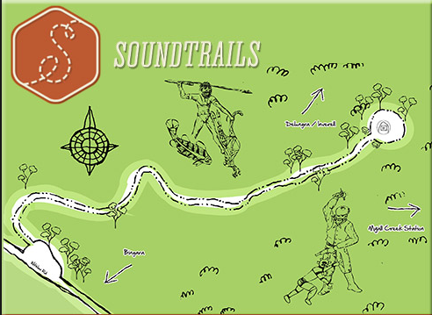
Myall Creek Memorial Site

A brief history of events
Following the arrival of the First Fleet in 1788 a pattern of relations developed between Aboriginal people and European settlers that would last for more than a century. Despite instructions from the British Colonial Office to treat Aboriginal people with goodwill and kindness, competition for land and resources following European expansion inevitably resulted in frontier conflict.
In response to the intensifying conflict the Colonial Administration ordered settlers to defend themselves and ordered Aboriginal people to stay away from European habitation. Aboriginal people were increasingly being viewed as a serious threat to settlers and it wasn't long before settlers took things into their own hands.
The massacre of approximately 30 Wirrayaraay people at Myall Creek on the 10 June 1838 was the culmination of a series of conflicts between settlers and Aboriginal people in the Liverpool Plains region.
The twelve men responsible for the massacre included freed and assigned convicts that had spent a day unsuccessfully pursuing Aboriginal people. When they came to Myall Creek station they discovered a group of Wirrayaraay. The Wirrayaraay were rounded up and tied together. A few minutes later they were led off and massacred. Two days later the men responsible for the massacre returned to the scene of the crime to burn the bodies.
The Myall Creek massacre was marked by a series of unusual circumstances for the time. First the massacre was reported to authorities by one of the station hands, then the Governor assigned a police magistrate to investigate the reports.
Eleven of the twelve settlers involved in the massacre were arrested for the murders but were found not guilty. Seven of the men were re-arrested and tried again. The second trial delivered a guilty verdict and the Judge sentenced all seven men to death.
On 18 December 1838, after all legal objections were exhausted and the Executive Council rejected petitions for clemency, the sentences were carried out. The hanging of the seven European settlers for their part in the Myall Creek massacre caused controversy throughout the colony. It led to heightened racial tensions and hardened settler attitudes towards Aboriginal people.

Questions:
- Why do you think Myall Creek is significant today?
__________________________________________________________________________________________________________________________________________

- Where did the name of the Wirrayaraay people derive from?
__________________________________________________________________________________________________________________________________________

- In the 1830’s why did the Europeans send their servants to the Myall Creek district?
__________________________________________________________________________________________________________________________________________

- Why did conflict arise between the Wirrayaraay and the Europeans?
__________________________________________________________________________________________________________________________________________

- What did the Wirrayaraay do?
__________________________________________________________________________________________________________________________________________

- What happened toward the end of 1837?
__________________________________________________________________________________________________________________________________________

- In May 1838, what was the initial relationship between the Wirrayaraay and the Europeans at Myall Creek like?
__________________________________________________________________________________________________________________________________________

- What date did the Myall Creek Massacre occur?
__________________________________________________________________________________________________________________________________________

- How many women, children and old men were murdered?
__________________________________________________________________________________________________________________________________________

- Why were there two trials for the murderers? (Think about what the word ‘acquitted’ means)
__________________________________________________________________________________________________________________________________________

- Why is the outcome of the second trial so significant to Australian history?
__________________________________________________________________________________________________________________________________________

- Did the massacres of Australia’s Indigenous people stop after Myall Creek?
__________________________________________________________________________________________________________________________________________

- When was the Myall Creek memorial site erected?
__________________________________________________________________________________________________________________________________________

- In your own words!!!! You are to write a one page response on the following question.

Why is it important for us to know about the Myall Creek Massacre and what did you learn from your visit to this site?

______________________________________________________________________________________________________________________________________________________________________________________________________________________________________________________________________________________________________________________________________________________________________________________________________________________________________________________________________________________________________________________________________________________________________________________________________________________________________________________________________________________________________________________________________________________________________________
_______________________________________________________________________________________________________________________________________________________________________________________________________________________________________________________________________________________________________________________________________________________________________________________
_______________________________________________________________________________________________________________________________________________________________________________________________________________________________________________________________________________________________________________________________________________________________________________________
_______________________________________________________________________________________________________________________________________________________________________________________________________________________________________________________________________________________________________________________________________________________________________________________
_______________________________________________________________________________________________________________________________________________________________________________________________________________________________________________________________________________________________________________________________________________________________________________________

