Overview
Write a definition for each of the following terms:
Suffrage
Democracy
Imperialism
Modernity
slavery
Colonies
Egalitarianism
Industrialisation
Settlers
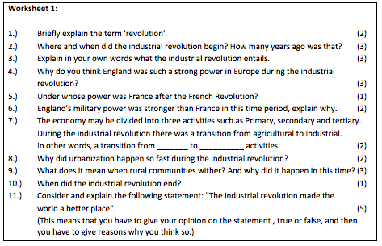

- What is the “triangle of trade”?
- What was traded using African labour?
- Why was the first manufactured gold coin in Britain named after an African town?
- What is a definition for a convict?
- Why were convicts originally sent to Australia?
- What is the ‘convict system’?
- Briefly explain what life was like for women?
- Describe the differences and similarities if any between slaves and convicts?
- How did the Industrial Revolution impact on the movement of people?
- Between 1788 and 1900, the Aboriginal population was reduced by:
a) 90% b) 86% c)68%
- Name the three main reasons for this.

Making a Nation
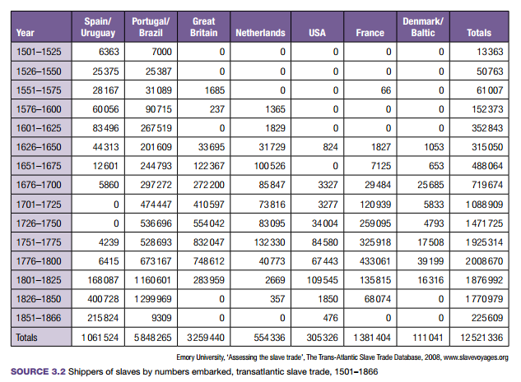
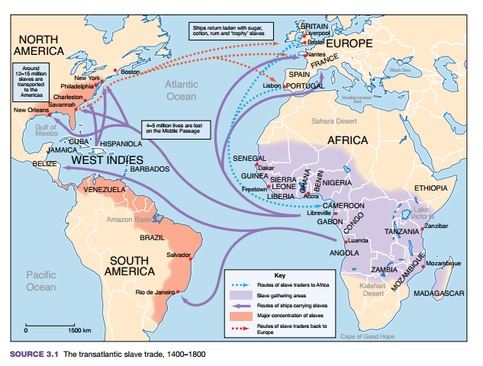
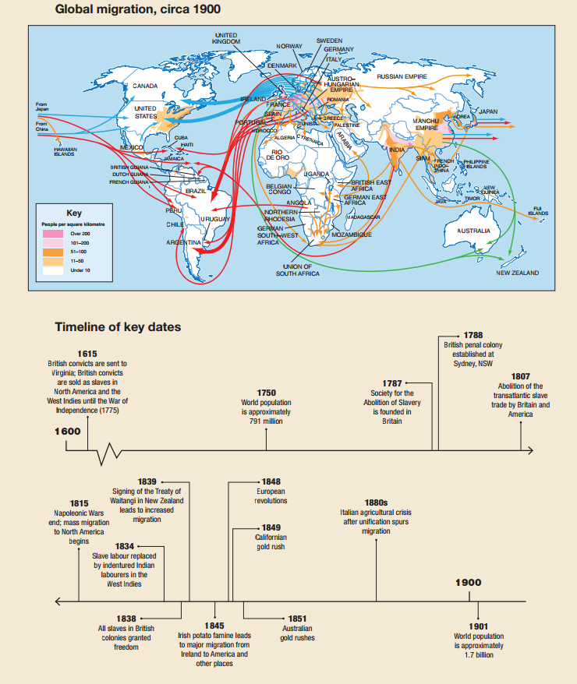

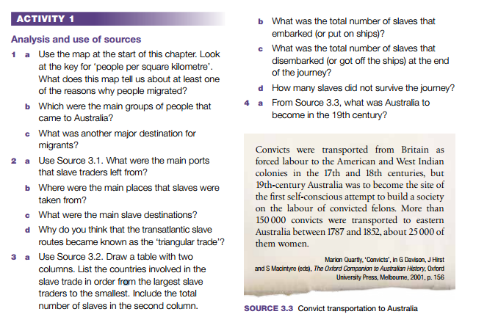

- Why were many working-class children forced to work?
- What were the most significant inventions of the late 1800s?
- List the various reasons why the Australian colonies decided to form a Federation.
- What role did Sir Henry Parkes play in pushing forward the Federation cause?
- What were three ways the new federal Constitution reduced the rights of Aboriginal Australians?
- Which colony first gave the vote to women?
- How did women draw attention to their cause?
- The indigenous population in 1788 is estimated to have been about 300 000. By how much had this changed in 1901 and why?
- Why did Chinese immigrants come to Australia: (a) before 1850 (b) between 1850 and 1880?
- How did European workers respond to the use of Chinese labour?
- Why were Pacific Islanders (Kanakas) brought to Queensland?
- What was ‘blackbirding’?
- Which two laws passed in 1901 prevented non- Europeans coming into Australia?

WW1
- List the members of Europe’s two rival power blocs.
- What were the main forms of competition between the great powers of the early twentieth century?
- Why did France seek revenge against Germany?
- Why was there tension between Austria–Hungary and Russia in the early 1900s?
- What is the significance of the date 28 June 1914?
- Give three reasons to explain why Australia became involved in World War I.
- What factors encouraged Australia as a nation to support the British war effort?
- What factors motivated individuals to enlist?
- What do the letters of the word ‘Anzac’ stand for?
- What was the purpose of trenches?
- Where was the Western Front?
- Why were there a high number of casualties in trench warfare?
- Why had a war of movement developed into a stalemate?
- What made the evacuation the only ‘successful’ aspect of the Gallipoli campaign?
- Create a timeline of the main events at Gallipoli between April and December 1915.
- What hardships of daily life did the Anzacs endure at Gallipoli?
- Why is the Gallipoli campaign seen as important to Australia’s national identity?
- What qualities does the Anzac legend identify as being typically Australian?

World War One ended in November, 1918. However, nobody called it ‘World War One’ at that time. How could they know that the effects of this war would cause another? It had been the most terrible war in history. Twenty million people had killed, half of them in combat. Many millions more were injured. The war cost nearly 36 billion. Towns and cities lay in ruins, good agricultural land was blasted and full of unexploded shells, railways, roads, factories and bridges were destroyed. Few people believed that there would be another war after such death and destruction. In fact, it was called for a time, ‘The War to End All Wars’.
Europe was very different at the end of the war. In 1914, Russia, Germany and the Austro-Hungarian Empire were all ruled by Emperors. In 1917, Russia underwent a Revolution in which the Communists seized power and shot the Tsar and his family. The Emperors of Germany and Austro-Hungarian were also forced to flee and give up their thrones and leave. At the start of the war both Britain and France had been wealthy countries but due to the cost of the war they were almost bankrupt by 1918.
Although the war was over, a peace settlement still had to be made. In Paris in 1919, the leaders of the victorious countries met to discuss this. They were dominated by ‘The Big Three’ who were Georges Clemenceau of France, the American President, Woodrow Wilson and David Lloyd George, Prime Minister of Britain. Germany was not invited to the peace conference.

Activities:
1. Copy and complete the paragraph below by filling in the missing words:
In November 19__, The First World War final came to an end. ______ million men had been killed in the fighting and over ______ million had been spent. In G_____ and the A_____ - H________ Empire, the Emperors had fled and in Russia, the C________ came to power. World War One was called The ‘War to ___ all ____’.

2. Why was the First World War called the ‘War to end all Wars’?
3. What was the name of the British Prime Minister in 1919?
4. Which country was not invited to the peace conference in Paris?
5. How do you think the country mentioned in your last answer would feel?

German Reaction to the Cease-fire
Many Germans were shocked when they heard the fighting was over. During the war, the German Government had practised strict censorship and hadn’t told their people of defeats. In 1917, Germany had even defeated the Russian Army. Many ordinary Germans believed that Germany was winning the war even in 1918.
On 7th November 1918, the French general Marshal Foch, received a small group of German generals at his headquarters in the Forest of Campiegne. They wanted an end to the war. Foch told them the Allied terms: Germans to leave all occupied territory, to surrender their arms and warships, withdraw all forces from west of the River Rhine. Marshall Foch gave the Germans 72 hours to decide their answer. He had it by the following day. On 10th November, the German Emperor fled; next day the new Government signed the Armistice (or cease-fire). Fighting stopped on all battlefronts at 11’O’ Clock on the 11th November 1918.
Many German soldiers felt bitterly betrayed. They said ‘they had been stabbed in the back’ by the new Government who they called ‘The November Criminals’. Here is one typical reaction:
The author was Adolf Hitler, then a German soldier recovering his sight after having been gassed in the war. By the phrase ‘gang of wretched criminals’ he meant the new German Government and by ‘Fatherland’ he meant Germany itself.

Activities
Source B: Adolf Hitler, 1923.
So it had all been in vain. In vain all the sacrifices and privations ... in vain the hours in which, with moral fear clutching at our hearts we nevertheless did our duty; in vain the deaths of two millions ... had they died for this? So that a gang of wretched criminals could lay their hands on the Fatherland?

- Why were so many Germans surprised when Germany lost the war?
- What were the terms of the cease-fire?
- How long were the Germans given to make up their minds?
- When and at what time did the fighting stop?
- Look at Source B. Why did so many Germans feel bitter about the cease-fire?
- Why did Adolf Hitler call the members of the German Government the ‘November Criminals’?

