YEAR 9 ADVANCED PRE-TEST EXAM QUESTIONS

1. FORMULAS ( 6 Marks )
a) Area of a Trapezium
A =

b) Surface Area
i) Cylinder: SA =

ii) Cone: SA =

iii) Sphere: SA =

c) Volume
i) Cone: V =

ii) Sphere: V =

2. Surface Area and Volume Questions ( 8 Marks)

a) Find the Surface Area of this Triangular Prism
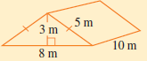

b) i) Find the perpendicular height of this cone.
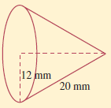
ii) Find the volume of this cone.

iii) Find the Surface Area of this cone.

3. Surds (8 Marks)
a) Simplify:
i) $\sqrt{18} ×8\sqrt{3}$

ii) $2\sqrt{27 }-4\sqrt{12}+3\sqrt{48}$

b) Expand and Simplify:
${(2\sqrt{3}-3)}^{2}$

c) Rationalise the denominator:
$$\frac{5}{4-\sqrt{6}}$$

